After the firing of Head Coach Jimbo Fisher, Athletic Director Ross Bjork held a press conference to detail the steps the Athletic Department will take following Fisher’s historic buyout and the plan for how the program will proceed with the search for a new head coach. At the presser, the Sports Editor provided live coverage via Twitter (X) in tandem with writing a brief. The Social Media Editor transferred photos to the Photo Editor in real time for live coverage via Stories while photographing the event. For the main feed, the Photo, Sports and Social Media desks collaborated to curate a long form carousel, recapping important details from the Bjork presser for readers in a consolidated and eye-catching form that encouraged engagement. Below are screenshots and links to their coverage.

Twitter/Instagram Story Integration

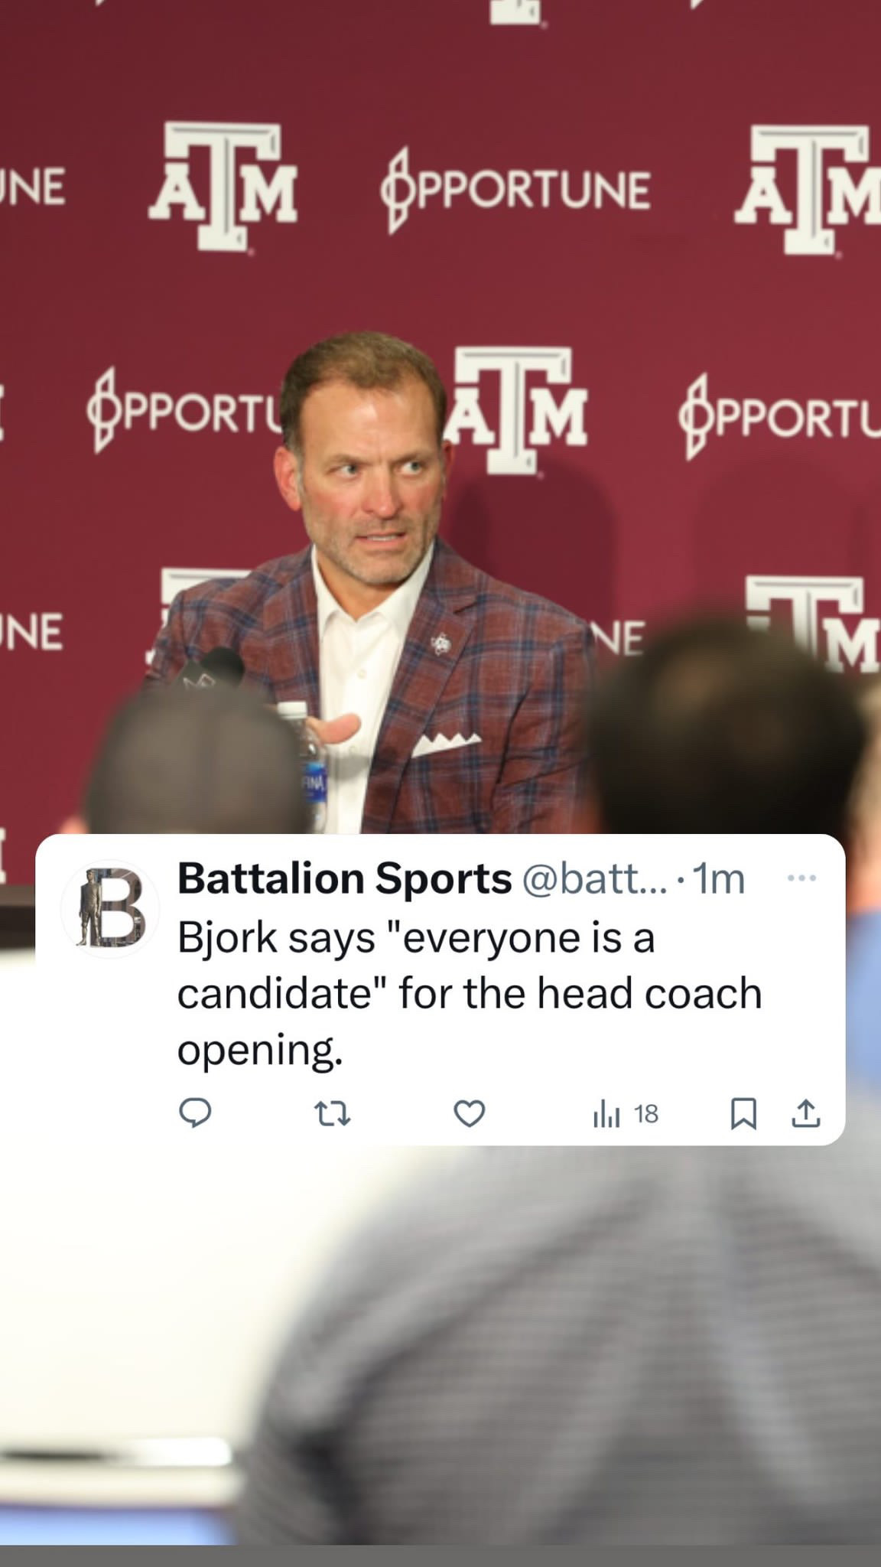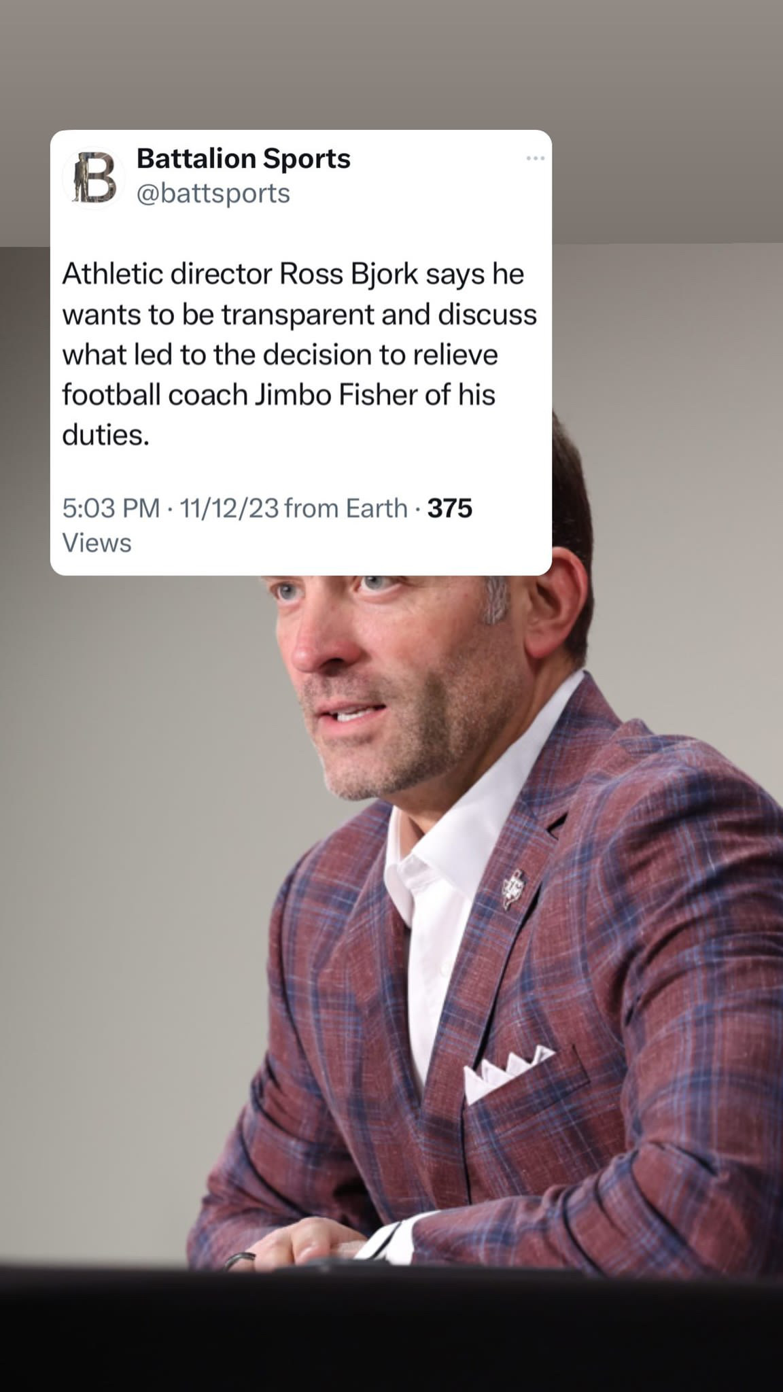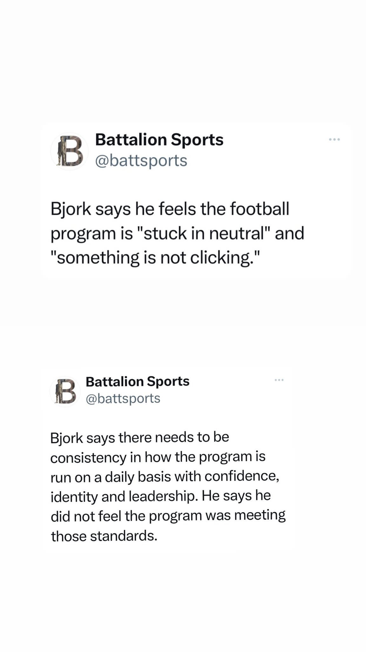

Instagram Long Form Post

